Individual Summary Report

The webpages which I was responsible for and therefore had a significant development role in were the FindItems, CoatNote and Coat webpages (the last of which has been transferred to another team member).

In the Find Items webpage, I used image mapping so that the user could click on each of the items – when clicked, an audio clip I recorded plays and a green tick appears over the item that was clicked on if it is correct. I used session storage so that depending on what vaccine the user picks, they may have to find a unique item to that vaccine in the FindItems webpage. The unique item personalises the game for the user and improves the user experience - I consider this a top feature of the game. I used timers to control the text on my webpages, to control when different images are shown and to control when the user can and cannot click on certain items.

Game Timer

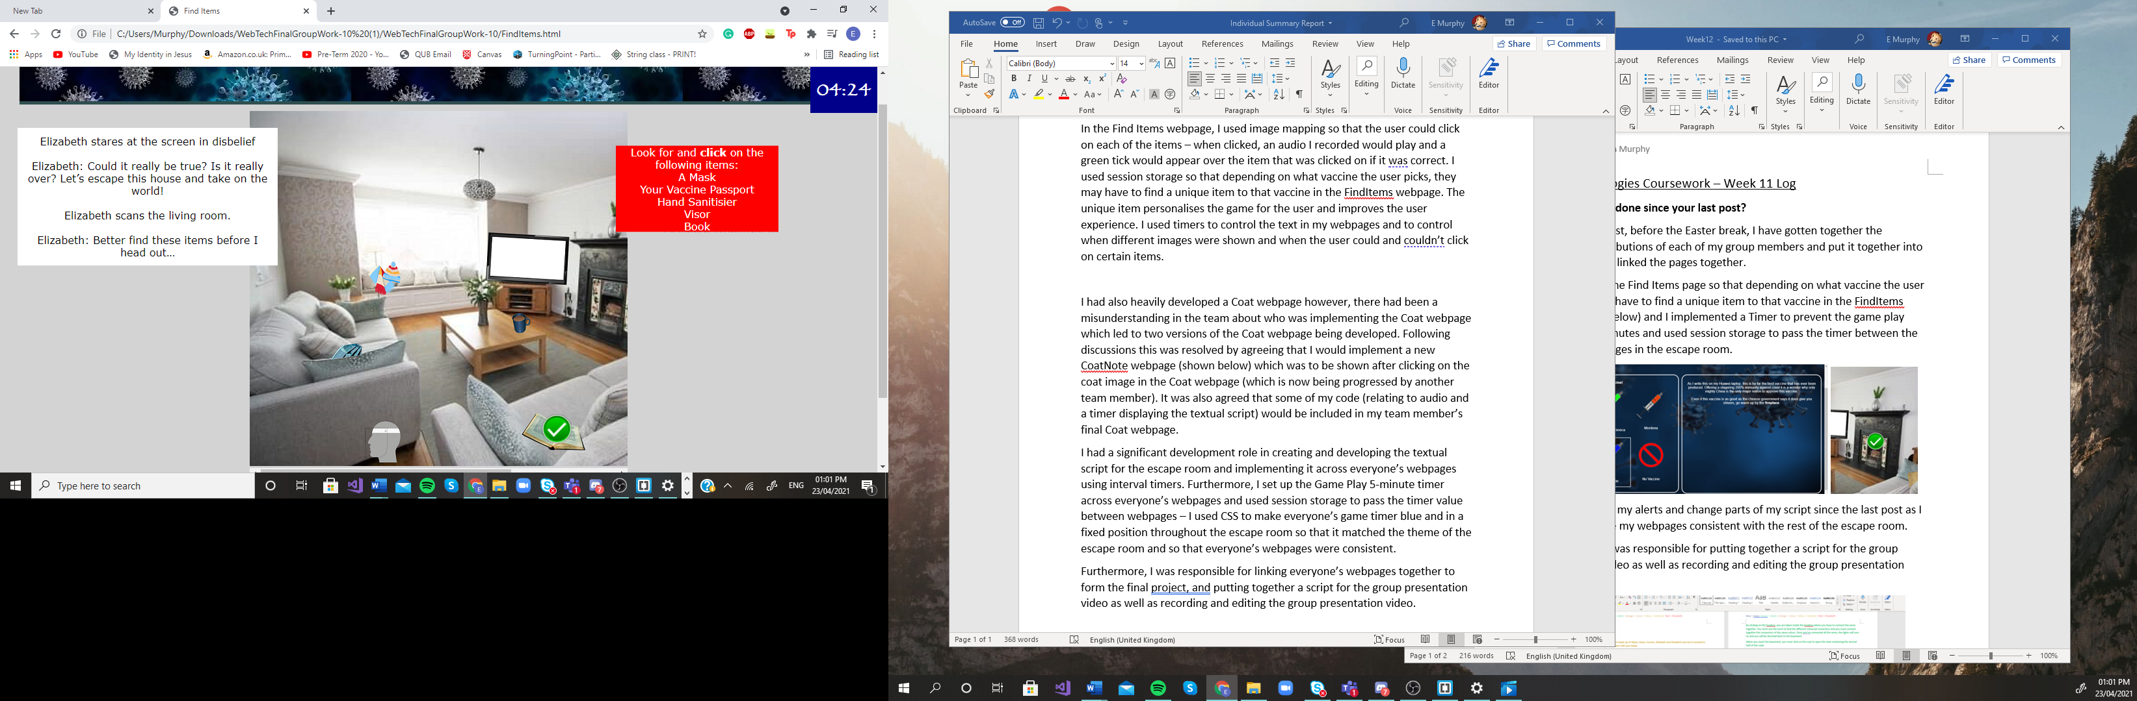

Textual script controlled using interval timers

Unique item dependant on vaccine selection

I had also developed the Coat webpage however, there had been a misunderstanding in the team about who was implementing the Coat webpage which led to two versions of the Coat webpage being developed. Following discussions, this was resolved by agreeing that I would implement a new CoatNote webpage (shown below) which was to be shown after clicking on the coat image in the Coat webpage (which is now being progressed by another team member and is now known as the Basement webpage). It was also agreed that some of my code (relating to audio and a timer displaying the textual script) would be included in my team member’s final Basement webpage.

Game Timer

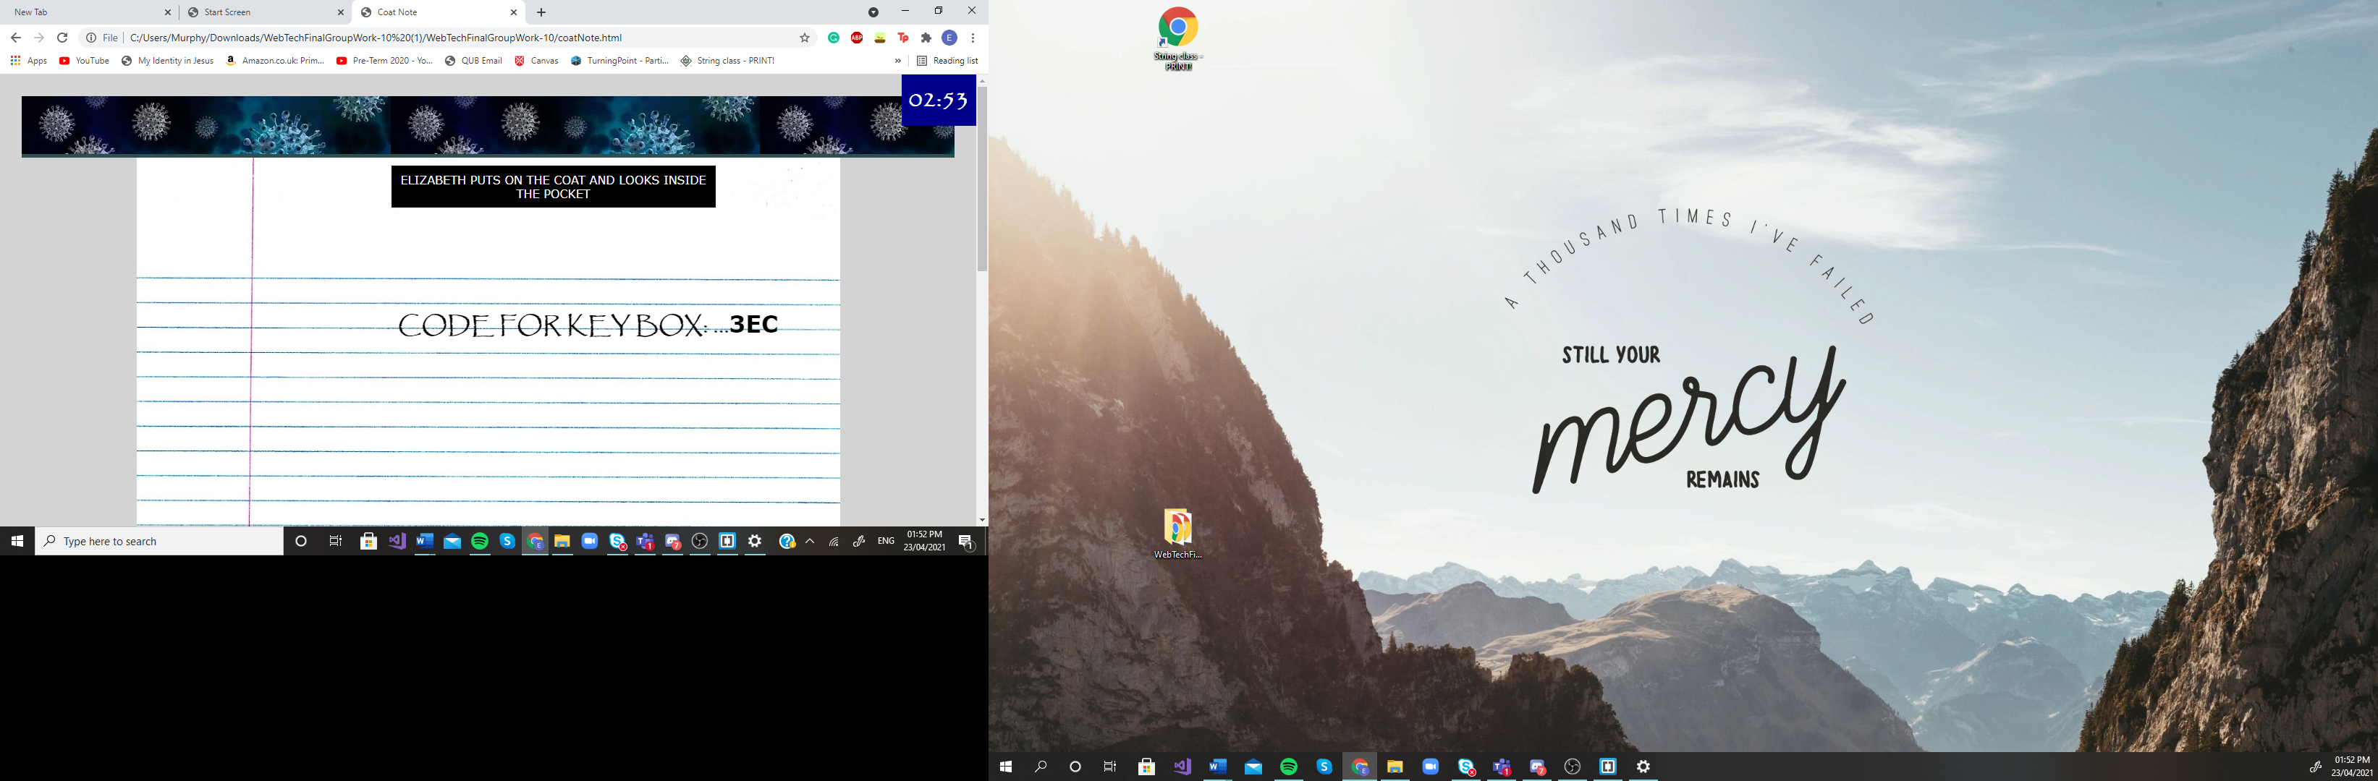

I had a significant development role in creating and developing the textual script for the escape room and implementing it across everyone’s webpages using interval timers (I have shown a sample of the code below) - I consider this a top feature of the game.

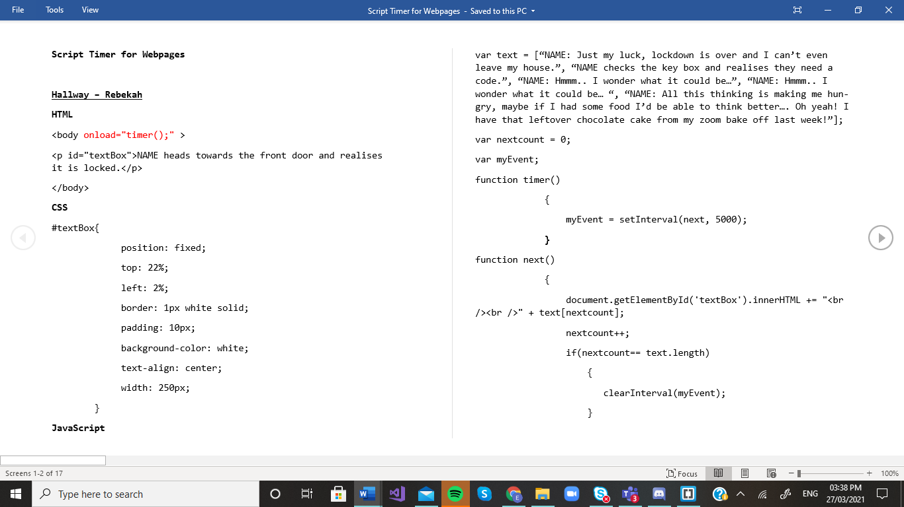

Furthermore, I set up the ‘Game Play’ 5-minute timer (see the groupTimer JavaScript file below) across everyone’s webpages and used session storage to pass the timer value between webpages – I also used CSS to make everyone’s game timer blue and in a fixed position throughout the escape room so that it matched the theme of the escape room and so that everyone’s webpages were consistent.

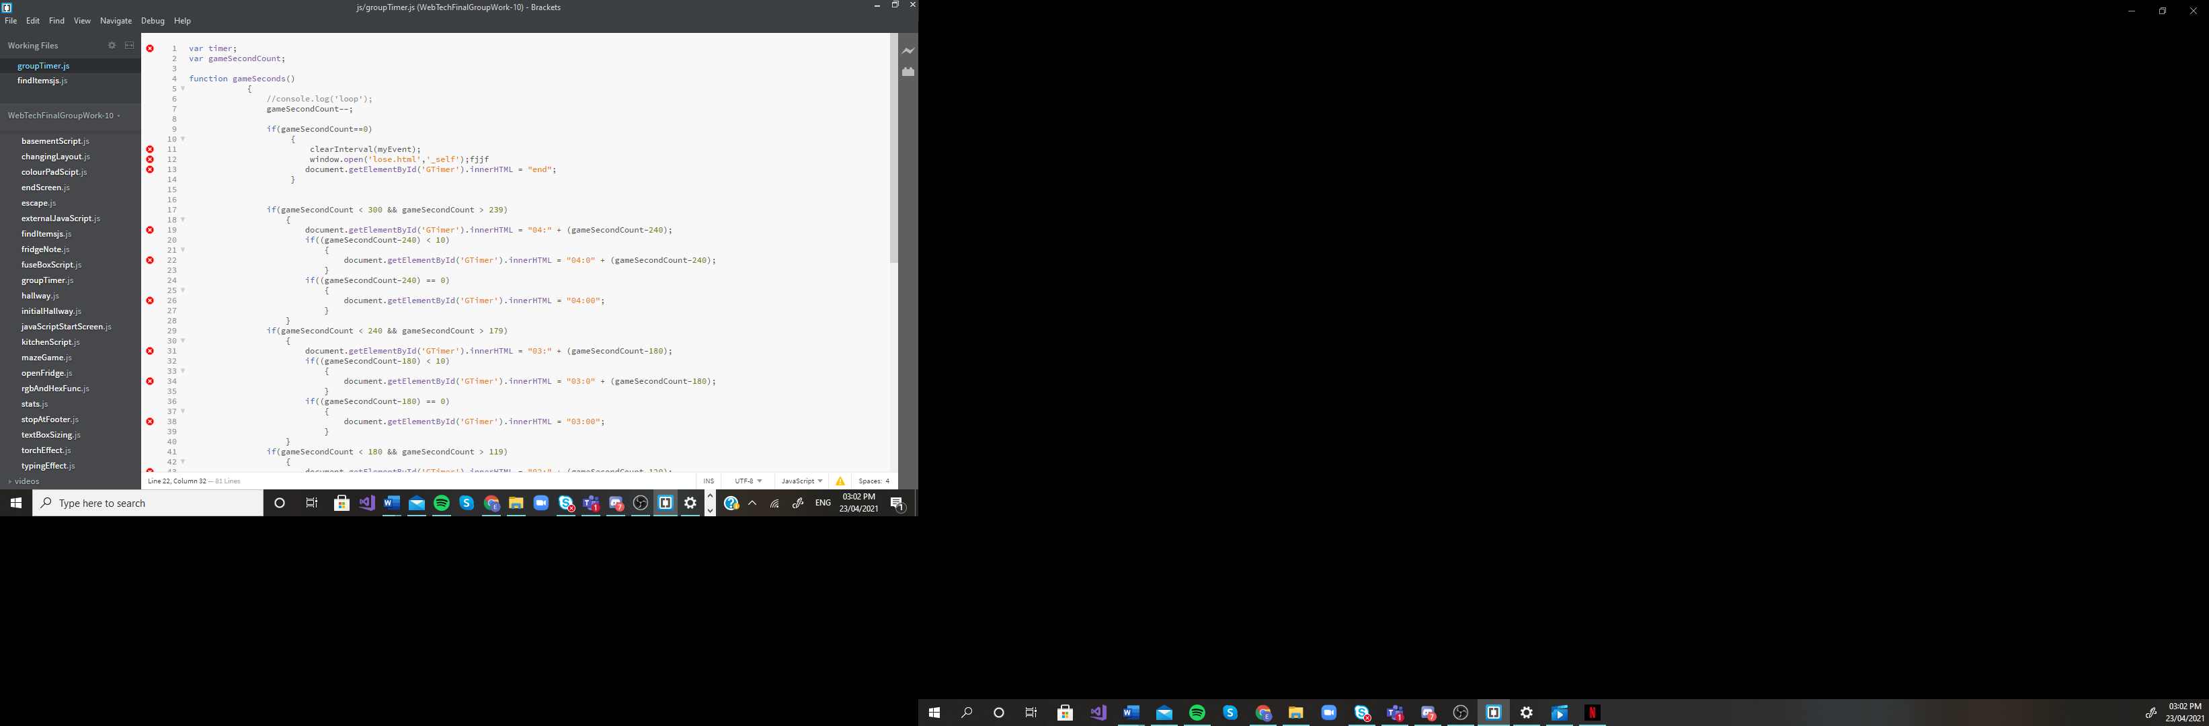 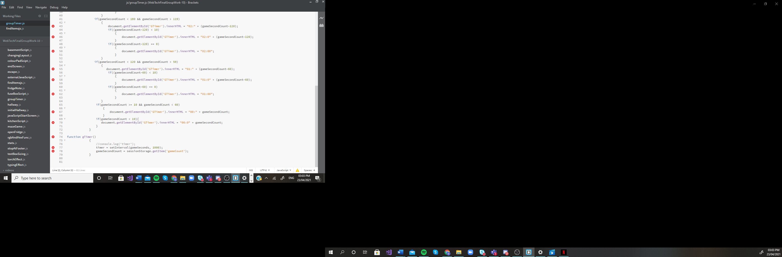

Furthermore, I was responsible for linking everyone’s webpages together to form the final project as well as recording, editing and writing a script for the group presentation video.